***INITIAL DATA ANALYSIS***

1.Given below screenshot refers the relationship between variables average amt_goods_price, name_type_suite and name_housing type

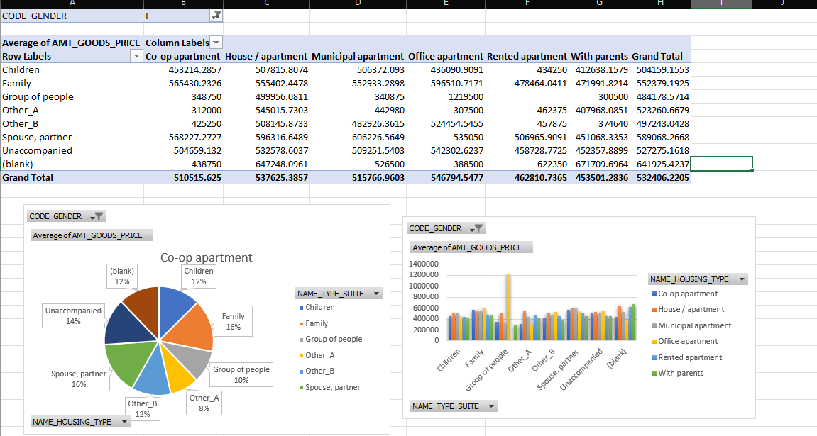

By observing data, we found that Family type suite has maximum (16 percent) of average amt of goods price in co-op apartment housing type.

2. Given below screenshot refers the relationship between variables average amt_goods_price, name_type_suite and Flag_own_car.

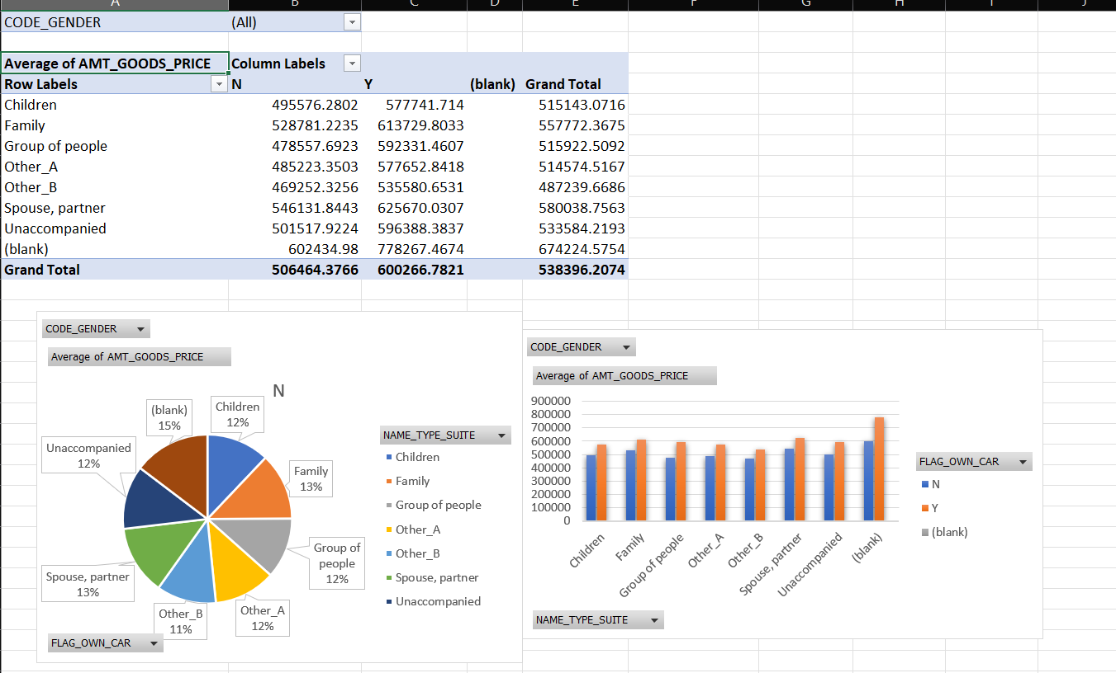

By observing data, we found that Family type suite has maximum (13 percent) of average amt of goods price in which who owns car.

3. Given below screenshot refers the relationship between variables average amt_goods_price, Name_family_status and name_education_type.

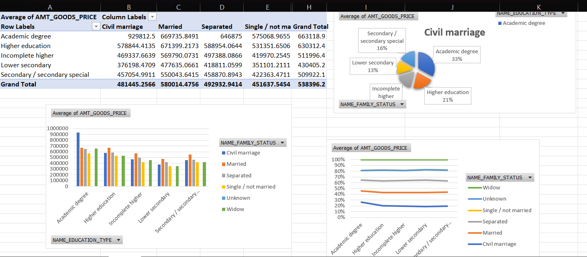

By observing data, we found that Academic degree in civil marriage has highest average of amt_goods_price.